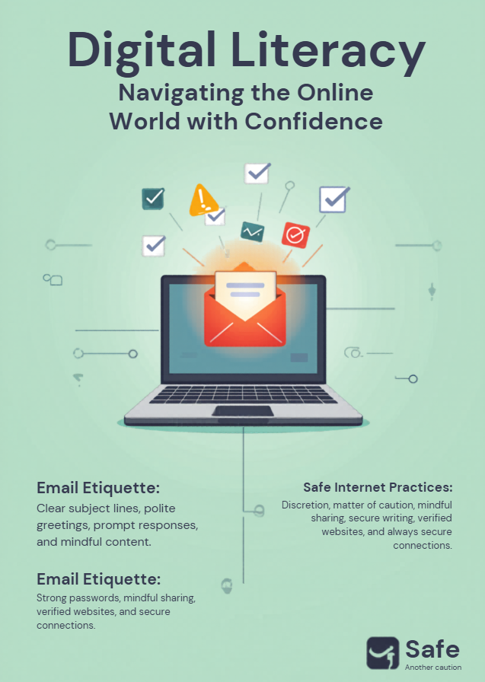

Digital literacy is the ability to navigate, evaluate, and create information using digital technologies. It goes beyond basic typing; it involves critical thinking to distinguish credible sources from misinformation and the technical skill to use various software and platforms effectively.
Email Etiquette
Professionalism in email builds trust and ensures clarity. Key practices include:
- Clear Subject Lines: Use concise summaries so recipients know the priority.
- Conciseness: Get to the point quickly while maintaining a polite tone.
- Judicious "Reply All": Only include those necessary to the conversation.
- Formal Closings: Use professional signatures with your contact details.
Safe Internet Practices
Protecting your "digital self" is essential in an era of frequent data breaches.
- Multi-Factor Authentication (MFA): Always enable an extra layer of security beyond just a password.
- Phishing Vigilance: Treat unsolicited links or attachments with skepticism, even if they look official.
- Password Hygiene: Use a password manager to maintain unique, complex credentials for every site.
- Privacy Awareness: Be mindful of your digital footprint and regularly audit the permissions granted to apps and social media platforms.
By mastering these three pillars, we ensure our online presence is both impactful and secure.

